Breast Cancer Detection

A PROJECT REPORT
Submitted by
PATEL DAKSH(21BECE30180)
PATEL DEV(21BECE30181)
PATEL AYUSH(21BECE30177)
In fulfillment for the award of the degree
of
BACHELOR OF ENGINEERING
in
CE-IT Department



LDRP Institute of Technology and Research, Gandhinagar
Kadi Sarva Vishwavidyalaya
April, 2025

LDRP Institute of Technology and Research Gandhinagar

CE-IT Department


CERTIFICATE
This is to certify that the Project Work entitled “Breast Cancer Detection” has been carried out by PATEL DAKSH(21BECE30180) under my guidance in fulfilment of the degree of Bachelor of Engineering in Computer Engineering Semester-8 of Kadi Sarva Vishwavidyalaya University during the academic year 2024-2025.

Prof. Tejasvee Gupta Prof. Ashish Patel
Internal Guide Head of the Department
LDRP ITR LDRP ITR
LDRP Institute of Technology and Research Gandhinagar

CE-IT Department

CERTIFICATE
This is to certify that the Project Work entitled “Breast Cancer Detection” has been carried out by PATEL DEV(21BECE30181) under my guidance in fulfilment of the degree of Bachelor of Engineering in Computer Engineering Semester-8 of Kadi Sarva Vishwavidyalaya University during the academic year 2024-2025.

Prof. Tejasvee Gupta Prof. Ashish Patel
Internal Guide Head of the Department
LDRP ITR LDRP ITR
LDRP Institute of Technology and Research Gandhinagar

CE-IT Department

CERTIFICATE
This is to certify that the Project Work entitled “Breast Cancer Detection” has been carried out by PATEL AYUSH(21BECE30177) under my guidance in fulfilment of the degree of Bachelor of Engineering in Computer Engineering Semester-8 of Kadi Sarva Vishwavidyalaya University during the academic year 2024-2025.

Prof. Tejasvee Gupta Prof. Ashish Patel
Internal Guide Head of the Department
LDRP ITR LDRP ITR
Presentation-I for Project-II
1. Name & Signature of Internal Guide
2. Comments from Panel Members
3. Name & Signature of Panel Members

Presentation-II for Project-II
1. Name & Signature of Internal Guide
2. Comments from Panel Members
3. Name & Signature of Panel Members

ACKNOWLEDGEMENT

Working in good environment and motivation enhance the quality of the work and we get it from our college through our Project. We have been permitted to take this golden opportunity under the expert guidance of Prof.Tejasvee Gupta from computer department of LDRP-ITR, Gandhinagar. We are heartily thankful to him to help complete our project successfully. He has given us his full experience and extra knowledge in practical field. We are also thankful to our head of department Prof. Ashish Patel and all computer staff to guide us. Finally, we thank all the people who had directly or indirectly help us to complete our project.

ABSTRACT

Breast cancer remains a significant public health challenge globally, demanding accurate and timely detection for effective treatment. Recent advancements in artificial intelligence (AI) and machine learning have shown promising results in automating the detection process, enhancing diagnostic accuracy, and reducing human error. This project focuses on developing an AI-driven system for breast cancer detection using a dataset of mammogram images. The system employs VGG16 to extract relevant features from mammogram images and classify them as either benign or malignant. The model is trained on a comprehensive dataset sourced from multiple medical institutions, ensuring robustness and generalizability. Evaluation metrics such as sensitivity, specificity, and area under the receiver operating characteristic curve (AUC-ROC) are utilized to assess the performance of the AI system. Results demonstrate that the proposed AI model achieves competitive accuracy(96%) compared to radiologists, offering a scalable solution to improve early detection and ultimately, patient outcomes in breast cancer diagnosis.

TABLE OF CONTENTS

Acknowledgement i
Abstract ii
Table of Contents iii
List of Figures iv
List of Tables v
- Introduction 1
  - Introduction
  - Scope
  - Project summary and Purpose
  - Overview of the project
  - Problem definition
- Technology and Literature Review 6
  - About Tools and Technology
  - Brief History of Work Done
- System Requirements Study 10
  - User Characteristics
  - Hardware and Software Requirements
    - Software requirements
    - Hardware requirements
  - Constraints
    - Hardware Limitations
    - Interfaces to Other Applications
    - Parallel Operations
    - Higher Order Language Requirements
  - Assumptions and Dependencies
- System Analysis 19
  - Study of Current System
  - Problem and Weaknesses of Current System
  - Requirements of New System
    - User Requirements
    - System Requirements
  - Feasibility Study
    - Does the system contribute to the overall objectives
of the organization?
    - Can the system be implemented using the current tech
nology and within the given cost and schedule constraints?
    - Can the system be integrated with other system which are
already in place?
  - Requirements Validation(is concerned with showing that the
requirements actually define the system which the customer wants)
  - Activity/Process In New System(Use event table)
  - Features Of New System
  - Class Diagram
  - System Activity(Use case and/or scenario diagram)
  - Object Interaction
  - Sequence and Collaboration Diagram
- System Design 37
  - System Application Design
    - Method Pseudo code
  - Database Design/Data Structure Design
    - Table and Relationship
    - Logical Description Of Data
  - Input/output and Interface Design
    - State Transition/UML Diagram
    - Samples Of Forms, Reports and Interface
- System Testing 45
  - Test cases
- Future Scope 49
- Conclusion 51
- Bibliography 53

LIST OF FIGURES

NO | NAME | PAGE NO
1 | Class Diagram | 33
2  3  4 | Use Case Diagram  Sequence Diagram  UML Diagram | 34  36  42

LIST OF TABLES

NO | NAME | PAGE NO
1 | Login Details | 39
2  3  4 | Patient Details  Image Details  Location Details | 39  40  40

1 INTRODUCTION

- INTRODUCTION

- SCOPE

- PROJECT SUMMARY AND PURPOSE

- OVERVIEW OF PROJECT

- PROBLEM DEFINITION

1.1 Introduction
Breast cancer remains one of the most prevalent forms of cancer affecting women worldwide. Early detection plays a pivotal role in improving survival rates and treatment outcomes. With the advent of artificial intelligence (AI) and machine learning (ML), there has been a significant advancement in the field of medical diagnostics, particularly in automating the detection of breast cancer from medical imaging data.
This project aims to explore the application of AI techniques in detecting breast cancer from mammography images. By leveraging deep learning algorithms and computer vision, we seek to develop a system that can accurately identify suspicious regions indicative of malignancy. The ultimate goal is to assist radiologists in making more informed decisions, thereby enhancing diagnostic accuracy and efficiency.
In this report, we will discuss the methodology employed, the dataset used for training and evaluation, the design and implementation of the AI model, experimental results, and the implications of our findings. By harnessing the power of AI in healthcare, we endeavor to contribute to the ongoing efforts in early detection and treatment of breast cancer.

1.2 Scope
The scope this project encompasses several key aspect.
1. Dataset Selection and Preparation
- Identification and acquisition of a suitable dataset containing mammography images with annotated ground truth labels.
- Preprocessing of the dataset to ensure uniformity, quality, and compatibility with AI model requirements.
2. AI Model Development
- Exploration and implementation of deep learning architectures such as convolutional neural networks (CNNs) tailored for medical image analysis.
- Training of the AI model using the prepared dataset to learn to detect potential abnormalities indicative of breast cancer.
3. Evaluation Metrics:
- Definition and utilization of appropriate metrics (e.g., accuracy, precision, recall, F1-score) to evaluate the performance of the AI model.
- Comparison of the model's performance against baseline methods or existing state-of-the-art approaches in breast cancer detection.
4. User Interface Design (Optional)
- Development of a user-friendly interface for visualizing model predictions and facilitating interaction with medical professionals.
- Integration of features for interpreting model outputs and providing actionable insights.
5. Ethical and Regulatory Considerations:
- Examination of ethical implications regarding patient privacy, data security, and responsible AI deployment in healthcare settings.
- Compliance with relevant regulatory frameworks (e.g., GDPR, HIPAA) governing the use of medical data and AI technologies.
6. Limitations and Future Directions:
- Identification and discussion of potential limitations of the developed AI model, such as dataset biases, interpretability issues, and generalizability to diverse patient demographics.
- Proposal of future research directions to address these limitations and enhance the robustness and efficacy of AI-driven breast cancer detection systems.

1.3 Project Summary and Purpose

The breast cancer detection project aims to develop a machine learning model that can accurately classify mammogram images as either indicative of benign or malignant breast tissue. By leveraging advanced image processing techniques and deep learning algorithms, the project seeks to enhance early detection rates and improve patient outcomes through timely intervention.
The primary purpose of this project is to harness the power of artificial intelligence to assist healthcare professionals in diagnosing breast cancer more effectively. By automating the analysis of mammogram images, the project aims to reduce diagnostic errors, expedite the review process, and ultimately contribute to saving lives by detecting breast cancer at its earliest stages.

1.4 Overview of Project
This project explores the application of artificial intelligence (AI) in automating the detection of breast cancer using mammogram images. Leveraging convolutional neural networks (CNNs), the system aims to classify mammograms into benign and malignant categories with high accuracy. The methodology includes dataset collection from diverse medical sources, preprocessing to enhance image quality, and training of the AI model to optimize sensitivity and specificity. Evaluation metrics such as sensitivity, specificity, and AUC-ROC curves assess the model's performance, comparing it with traditional radiological interpretations. The study discusses the potential of AI to improve early detection rates, reduce human error, and enhance overall efficiency in breast cancer screening, paving the way for more effective clinical applications and patient care.
.
1.5 Problem Definition
Breast cancer remains a significant concern globally, with early detection playing crucial role in improving survival and treatment outcomes. However, current screening methods, such as mammography, are limited by the subjectivity of human interpretation and variations in expertise among radiologists. This project aims to address these challenges by developing an AI-driven system for automated breast cancer detection. The primary objective is to create a robust model capable of accurately analyzing mammogram images to detect and classify suspicious lesions with high sensitivity and specificity. The project seeks to overcome the limitations of traditional screening methods by leveraging machine learning algorithms, specifically convolutional neural networks (CNNs), trained on a diverse dataset of mammogram images. The goal is to enhance diagnostic accuracy, reduce false positives, and facilitate early intervention, thereby improving overall patient care and outcomes in breast cancer diagnosis.

2 TECHNOLOGY AND LITERATURE REVIEW

- TOOLS AND TECHNOLOGY

- BRIEF HISTORY OF WORKDONE

  - Tools and Technology

- Programming Languages:
Python (for its extensive ML libraries).

- Libraries and Frameworks:
TensorFlow, PyTorch (for deep learning), scikit-learn (for machine learning), Keras (for neural networks).

- Image Processing and Computer Vision:
OpenCV (Python Imaging Library).

- Deep Learning Models:
VGG16(For feature extraction)

- Data Handling and Preprocessing:
Pandas, NumPy.

- Deployment and Integration:
Flask, Html,css,js (web frameworks).

- Version Control and Collaboration:
Git, GitHub, GitLab, Bitbucket.

- Visualization and Reporting:
Matplotlib, Seaborn (visualization), TensorBoard (model visualization).

- data set :
https://www.kaggle.com/datasets/vuppalaadithyasairam/ultrasound-breast-images-for-breast-cancer/data
These tools and technologies provide a comprehensive toolkit for developing, deploying, and maintaining AI solutions for breast cancer detection, ensuring efficiency and accuracy throughout the project lifecycle.

  - Brief History of Work Done
1. Preprocessing:
1.1 Read the mammogram image
1.2 Convert the image to grayscale if necessary
1.3 Apply noise reduction techniques (e.g., Gaussian blur, median filter)
1.4 Enhance contrast if needed (e.g., histogram equalization)

2. Segmentation:
2.1 Apply segmentation techniques to isolate potential regions of interest (ROIs)
- Thresholding (e.g., global, adaptive)
- Edge detection (e.g., Canny edge detector)
- Region growing
2.2 Refine segmentations to reduce false positives and enhance true positives
- Morphological operations (e.g., erosion, dilation, opening, closing)
- Connected component analysis

3. Feature Extraction:
3.1 Extract features from segmented ROIs
- Shape features (e.g., area, perimeter, circularity)
- Texture features (e.g., gray-level co-occurrence matrix (GLCM), gray-level run- length matrix (GLRLM))
- Intensity features (e.g., mean, standard deviation)
3.2 Normalize extracted features to a consistent scale if necessary

4. Classification:
4.1 Train a classifier using the extracted features and labeled data (e.g., benign vs. malignant)
- Deep learning models (e.g., VGG16)
4.2 Evaluate the trained classifier using cross-validation techniques
4.3 Apply the classifier to classify new ROIs

5. Post-processing:
5.1 Analyze classified results and perform post-processing steps
- Remove small false positives
- Merge overlapping detections
5.2 Generate final output indicating regions classified as potentially cancerous

6. Reporting:
6.1 Output results in a human-readable format (e.g., text report, graphical representation)
6.2 Include metrics such as accuracy, sensitivity, specificity, and ROC curve if applicable

3 SYSTEM REQUIREMENTS STUDY

- USER CHARACTERISTICS

- HARDWARE AND SOFTWARE REQUIREMENTS

- CONSTRIANTS

- ASSUMPTIONS AND DEPENDENCIES

3.1 User Characteristics
Demographic Information: Describe the demographic characteristics of the target users. This includes age range, gender distribution (if relevant), and any other pertinent demographic factors that may influence the use or applicability of the AI system.
Medical Background: Detail the medical background or status of the users. For instance, are they patients undergoing screening, healthcare professionals using the tool for diagnosis, or researchers evaluating the AI's performance?
Technical Proficiency: Assess the technical proficiency of the users with respect to using AI-based tools. This can range from healthcare professionals with varying levels of familiarity with AI technologies to patients who may not have technical expertise but need to understand basic instructions for using the system.

3.2 Software and Hardware Requirements

Software and Hardware Requirements are used to describe the minimum hardware and software requirements to run the Software. These requirements are described below.

3.2.1 Software Requirements

- Client:

- Operating System: Windows, Android or Linux

- Server:

- Operating System: WINDOWS or LINUX SERVER OS
- Database Server: Oracle
- Technologies: Jupyter Notebook,python
- ML Frameworks: TensorFlow, PyTorch, Keras, and scikit-learn
- Libraries: NumPy, Pandas, and Matplotlib

3.2.2 Hardware Requirements

  - Client:
- Android version 8
- 6 GB RAM
- Internet Connection
  - Server:
    - A modern multicore processor, such as an Intel Core i5 or i7
    - 8 GB of RAM
    - Internet Connection
    - Nvidia GPUs
    - Solid-state drives (SSDs) are recommended for fast access to data.

3.3 Constraints :

3.3.1 Hardware Limitation:
• Computational Power: Algorithms used for breast cancer detection often require significant computational resources, especially if deep learning models are involved. Limited computational power can restrict the complexity of models that can be deployed or the speed at which they can process data.
• Memory: Large datasets and complex models require ample memory to store intermediate computations and model parameters. Insufficient memory can lead to slower processing times or even prevent the deployment of certain algorithms.
• Storage: Datasets used for training and testing machine learning models in breast cancer detection can be large, especially if high-resolution medical imaging data (like mammograms) are involved. Limited storage capacity can restrict the size of datasets that can be used or stored.
• Sensor Quality: If the project involves hardware sensors (such as imaging devices), limitations in sensor resolution or accuracy can impact the quality of input data. Lower-quality sensors may lead to less reliable results in cancer detection.
• Real-time Processing: For applications requiring real-time or near-real-time detection (such as during medical imaging procedures), hardware limitations in processing speed can delay results or make real-time analysis unfeasible.
• Connectivity: Some applications might require continuous data transmission or remote monitoring. Limited network connectivity can hinder the feasibility of such applications, especially in remote or resource-limited areas.
• Power Constraints: Mobile or portable applications may be constrained by battery life or power availability. This can restrict the duration or frequency of use before recharging or replacing batteries.

3.3.2 Interfacec to other Applications:
1. Data Compatibility: Understand the supported data formats (e.g., DICOM) for seamless integration with other healthcare applications.
2. Security and Privacy: Ensure that patient data is securely transmitted and stored, following healthcare regulations to protect confidentiality.
3. Interoperability: Verify that the interface can integrate with existing Electronic Health Record (EHR) systems and PACS for efficient data exchange.
4. Performance Requirements: Be aware of expected data transfer speeds, response times, and system availability to manage workflow efficiently.
5. Error Handling and Logging: Know the procedures for identifying and resolving interface errors to minimize disruptions in data exchange.
6. Version Control and Compatibility: Understand versioning protocols to manage updates and ensure compatibility with connected applications.
7. User Access Control: Follow access control policies to manage permissions and ensure authorized access to sensitive data.
8. Scalability and Resource Management: Consider system scalability to handle increasing data volumes and processing demands effectively.
9. Documentation and Training: Access resources for understanding interface functionalities, data exchange protocols, and troubleshooting.
10. Compliance and Regulatory Requirements: Adhere to regulatory standards for healthcare data exchange to ensure legal compliance and ethical data handling.
These sorted constraints provide users with clear guidelines and considerations when interacting with interfaces to other applications within the breast cancer detection system using image processing.

3.3.3 Parallel Operations:
1. Image Preprocessing
Task: Preprocessing mammogram images to enhance quality and prepare them for feature extraction and classification.
Parallelization: Divide the dataset into batches processed concurrently by multiple threads or GPUs.
Benefit: Accelerates the overall preprocessing time, enabling faster analysis of images.
2. Feature Extraction
Task: Extracting relevant features from mammogram images that can indicate potential cancerous regions.
Parallelization: Utilize parallel algorithms to extract features from different image regions simultaneously.
Benefit: Reduces the time required for feature extraction, crucial for timely diagnosis.
3. Deep Learning Model Training
Task: Training deep learning models on labeled mammogram datasets.
Parallelization: Distribute training batches across multiple GPUs or utilize distributed training frameworks.
Benefit: Speeds up the training process, allowing for quicker experimentation with different model architectures and hyperparameters.
4. Model Evaluation and Validation
Task: Evaluating trained models using validation datasets to assess their accuracy in detecting breast cancer.
Parallelization: Run evaluation tasks concurrently on different subsets of the validation dataset.
Benefit: Efficiently assess model performance across multiple metrics, aiding in the selection of the best-performing model.
5. Real-Time Inference
Task: Performing real-time inference on new mammogram images to detect potential cancerous regions during medical examinations.
Parallelization: Deploy models using multi-threading or distributed computing to handle simultaneous inference requests.
Benefit: Enables timely detection and immediate feedback during medical procedures, enhancing diagnostic capabilities.
6. Optimization and Fine-Tuning
Task: Optimizing model parameters and fine-tuning architectures to improve detection accuracy.
Parallelization: Conduct hyperparameter tuning using parallel jobs or distributed frameworks like TensorFlow or PyTorch.
Benefit: Speeds up the iterative process of model refinement, leading to better performance in detecting breast cancer.
7. Data Pipelines and Integration
Task: Managing data pipelines to streamline the flow of images, annotations, and model outputs throughout the detection process.
Parallelization: Implement parallel processing in data pipelines to handle large volumes of data efficiently.
Benefit: Ensures smooth integration between different stages of the AI system, from data ingestion to result visualization.

3.3.4 Higher Order Language Requirements
1. Machine Learning and Deep Learning Frameworks
Requirement: Utilize robust frameworks like TensorFlow, PyTorch, or Keras for developing and training machine learning models.
Importance: These frameworks provide high-level APIs and pre-implemented algorithms essential for detecting patterns indicative of breast cancer in medical images.

2. Statistical Analysis and Algorithm Implementation
Requirement: Use languages such as Python, R, or Julia for statistical analysis, data manipulation, and algorithm development.
Importance: These languages offer extensive libraries (e.g., scikit-learn, NumPy, pandas in Python) that facilitate data preprocessing, feature engineering, and evaluation of machine learning models.

3. Parallel and Distributed Computing
Requirement: Familiarity with frameworks like Apache Spark, Dask, or MPI (Message Passing Interface) for parallel and distributed computing.
Importance: Necessary for handling large-scale datasets and optimizing computational tasks across multiple processors or nodes, enhancing the efficiency of model training and evaluation.

4. Data Visualization and Interpretation
Requirement: Knowledge of libraries like Matplotlib, Seaborn (Python), or Plotly for visualizing medical imaging data, model outputs, and evaluation metrics.
Importance: Effective visualization aids in understanding complex datasets, communicating findings to medical professionals, and validating model performance.

3.4 Assumption and Dependencies:

In developing a breast cancer detection AI project, several critical assumptions and dependencies shape its feasibility and success. Assumptions include the availability of sufficient and accurately labeled mammogram datasets essential for training robust AI models. Additionally, there is an assumption that state-of-the-art machine learning algorithms, particularly deep learning models like convolutional neural networks (CNNs), will achieve high accuracy in detecting cancerous abnormalities from mammogram images. Dependencies include access to expert domain knowledge in radiology and oncology to ensure the clinical relevance and accuracy of AI predictions. Furthermore, the project relies heavily on adequate computational resources, such as GPUs and high-performance computing clusters, to facilitate efficient model training and deployment. Regulatory compliance, including adherence to healthcare data privacy laws and ethical guidelines, is also crucial, underscoring dependencies on obtaining necessary approvals for handling sensitive patient data and deploying AI solutions in clinical settings.

Managing these assumptions and dependencies is pivotal for mitigating risks and ensuring the project's successful execution. Effective risk management strategies involve continuous monitoring of data quality and availability, proactive collaboration with medical professionals to validate AI outputs, and securing robust computational infrastructure to support the intensive computing demands of AI model development. Clear communication with stakeholders, including regulatory bodies and healthcare providers, is essential to navigate ethical considerations and ensure compliance with legal standards throughout the project lifecycle. By addressing these factors comprehensively, the breast cancer detection AI project can advance with confidence towards its objectives of improving diagnostic accuracy and patient outcomes in clinical practice.

4 SYSTEM ANALYSIS

- STUDY OF CURRENT SYSTEM

- PROBLEM AND WEAKNESS OF CURRENT SYSTEM

- REQUIREMENETS OF NEW SYSTEM

- FEASIBILITY STUDY

- REQUIREMENTS VALIDATION

- ACTIVITY/PROCESS IN NEW SYSTEM

- FEATURES OF NEW SYSTEM

- CLASS DIAGRAM

- USECASE DIAGRAM

- OBJECT INTERATION

- SEQUENCE DIAGRAM

4.1 Study of current system
1. Mammography
Description: Mammography is the most common and widely used imaging modality for breast cancer screening and diagnosis.
Technology: Digital mammography uses x-rays to create detailed images of the breast tissue, which are analyzed for abnormalities such as masses or microcalcifications.
Advancements: Tomosynthesis (3D mammography) provides clearer three-dimensional images, improving the detection of breast tumors, especially in dense breast tissue.
2. Ultrasound Imaging
Description: Breast ultrasound uses high-frequency sound waves to produce images of the breast tissue.
Use Cases: It is often used as a supplementary imaging tool to further evaluate abnormalities detected on mammography or for imaging dense breast tissue that may be difficult to assess with mammography alone.
Advantages: Ultrasound is particularly useful for distinguishing between solid masses and fluid-filled cysts.
3. MRI (Magnetic Resonance Imaging)
Description: Breast MRI uses a magnetic field and radio waves to create detailed images of the breast tissue.
Applications: It is highly sensitive and is used for screening high-risk individuals, evaluating the extent of cancer spread (staging), and assessing breast implants.
Advantages: MRI can detect smaller lesions and is especially useful in dense breast tissue and for evaluating multifocal or multicentric cancer.
4. Biopsy and Pathology
Description: Biopsy involves removing tissue samples from the breast for examination under a microscope to determine if cancer or other abnormalities are present.
Types: Core needle biopsy and surgical biopsy (excisional biopsy) are common methods.
Analysis: Pathologists analyze biopsy samples to provide a definitive diagnosis of breast cancer and determine its characteristics, such as subtype and grade.
5. Digital Breast Tomosynthesis (DBT)
Description: DBT, or 3D mammography, is an advanced form of mammography that captures multiple images of the breast from different angles.
Benefits: It reduces overlapping breast tissue that can obscure cancerous lesions in traditional mammography, leading to improved cancer detection rates and fewer false positives.
6. Automated Breast Ultrasound (ABUS)
Description: ABUS is a system that uses an automated scanning arm to acquire 3D ultrasound images of the entire breast.
Purpose: It is used as an adjunct to mammography for screening women with dense breast tissue and improving the detection of breast cancers that may be hidden on mammography.
7. Genetic Testing
Description: Genetic testing involves analyzing DNA to identify mutations that may increase the risk of breast cancer (e.g., BRCA1 and BRCA2 mutations).
Use Cases: It is used to assess hereditary risk and inform screening and prevention strategies for individuals and their families.

4.2 Problem and Weakness of Current System
Physical breast cancer detection methods, such as clinical breast exams (CBE) and self-examinations, have several limitations and weaknesses:
Effectiveness and Reliability:
Clinical breast exams (CBE) performed by healthcare professionals can vary in effectiveness depending on the skill and experience of the examiner. Small tumors or those deep within the breast tissue may be missed.
Self-examinations are often recommended for early detection, but they can lead to false positives (detecting a lump that is not cancerous) or false negatives (missing a cancerous lump).
Subjectivity and Interpretation:
Physical exams rely on the interpretation of palpable changes in breast tissue. What one examiner perceives as abnormal may differ from another's assessment, leading to inconsistencies in detection.
Limited Sensitivity:
Physical exams may not detect certain types of breast cancers early enough. Some cancers may grow rapidly or be located in areas not easily accessible through physical examination alone.
Lack of Standardization:
Techniques for clinical breast exams can vary among healthcare providers and across different healthcare settings, leading to inconsistencies in the detection process.
Dependency on Patient Compliance:
Self-examinations require patients to perform regular checks, which may not always happen due to factors such as lack of awareness, discomfort, or forgetfulness.
Supplemental Testing Needed:
Physical exams are often supplemented by imaging tests such as mammography, ultrasound, or MRI for more accurate detection and diagnosis. Relying solely on physical exams may delay the detection of cancers that are not palpable.
Emotional and Psychological Impact:
False positives from physical exams can cause unnecessary anxiety and stress for patients, while false negatives can provide a false sense of security.

4.3 Requirements of New System
4.3.1 User Requirements
Accuracy and Reliability:
Users expect AI systems to provide highly accurate and reliable detection of breast cancer. This includes the ability to detect small tumors, distinguish between benign and malignant lesions, and reduce false positives and false negatives compared to traditional methods.
Early Detection:
AI systems should facilitate early detection of breast cancer, which is crucial for improving treatment outcomes and survival rates. This involves identifying abnormalities at stages when they are not yet palpable or visible on imaging.
Integration with Existing Workflow:
Healthcare providers require AI solutions that seamlessly integrate into existing clinical workflows. This includes compatibility with electronic health records (EHR), imaging systems, and other diagnostic tools to streamline the diagnostic process.
Automation and Efficiency:
Users seek AI systems that automate routine tasks, such as image analysis and interpretation, reducing the workload on radiologists and healthcare providers. This can improve efficiency and allow for faster diagnosis and treatment planning.

4.3.2 System Requirements :
Enhanced Accuracy and Sensitivity:
AI algorithms can analyze large volumes of medical data with high accuracy and sensitivity, potentially detecting subtle abnormalities that may be missed by human observers. This can lead to earlier detection of cancers when treatment is more effective.
Efficiency and Workflow Improvement:
AI can automate and streamline routine tasks in cancer detection, such as analyzing medical images (like mammograms) and identifying suspicious areas for further review. This improves efficiency, reduces turnaround times for diagnoses, and allows healthcare providers to focus more on patient care.
Access to Expertise and Consistency:
AI systems can provide consistent and standardized assessments regardless of the expertise level of the healthcare provider or the geographical location of the healthcare facility. This helps bridge the gap in access to specialized healthcare services, particularly in rural or underserved areas.
Support for Clinical Decision-making:
AI can assist healthcare professionals by providing additional insights and data-driven recommendations. This supports clinical decision-making processes, helping to prioritize cases for further evaluation and treatment planning.
Early Detection and Improved Outcomes:
Early detection of cancer is crucial for improving patient outcomes and survival rates. AI algorithms can detect cancers at earlier stages when treatments are less invasive and more likely to be successful, ultimately saving lives.
Reduction of Healthcare Costs:
By facilitating earlier detection and more accurate diagnoses, AI systems can potentially reduce healthcare costs associated with advanced-stage cancer treatments and prolonged hospital stays. This can lead to more efficient allocation of resources within healthcare systems.

4.4 feasibility study:
4.4.1 Does the system contribute to the overall objectives of the organization?
Improving Patient Outcomes:
Early detection of breast cancer through AI can lead to earlier treatment initiation, which often results in better patient outcomes and increased survival rates. This aligns with the organization's objective of providing high-quality healthcare and improving patient well-being.
Enhancing Efficiency and Resource Utilization:
AI can streamline the diagnostic process by automating image analysis and triaging cases based on priority. This efficiency helps healthcare organizations manage their resources more effectively, reducing wait times for diagnosis and treatment.
Supporting Evidence-Based Decision Making:
AI systems provide healthcare providers with data-driven insights and recommendations, supporting evidence-based decision-making in diagnosis and treatment planning. This contributes to the organization's objective of delivering informed and effective healthcare services.
Promoting Innovation and Research:
AI enables the analysis of large datasets to uncover new patterns and biomarkers related to breast cancer detection and progression. This fosters innovation within the organization and contributes to ongoing research efforts aimed at improving diagnostic techniques and treatment outcomes.
Meeting Regulatory and Quality Standards:
By adopting AI systems for breast cancer detection, healthcare organizations can demonstrate compliance with regulatory standards and quality measures related to early detection and timely treatment of cancer. This ensures that patients receive care that meets established guidelines and benchmarks.
Enhancing Reputation and Patient Trust:
Investing in advanced technologies like AI for breast cancer detection can enhance the organization's reputation as a leader in innovative healthcare solutions. This fosters patient trust and confidence in the organization's ability to deliver cutting-edge care.
Addressing Healthcare Disparities:
AI can help bridge gaps in access to specialized healthcare services by providing consistent and reliable diagnostic assessments regardless of geographical location or healthcare provider expertise. This supports the organization's objective of promoting equitable healthcare delivery.

4.4.2 Can the system be implemented using the current technology and within the given cost and schedule constraints?

Technological Readiness:
AI algorithms for breast cancer detection have shown promising results in research and clinical trials. Technologies such as machine learning and deep learning frameworks are readily available and can be implemented to analyze medical images (e.g., mammograms, MRIs) for abnormalities indicative of cancer.
Data Availability and Quality:
Successful implementation depends on access to large, high-quality datasets of annotated medical images for training AI models. Healthcare organizations must ensure they have sufficient data that is diverse and representative of different demographics and cancer types to achieve robust performance.
Computational Infrastructure:
AI models for medical image analysis often require significant computational resources, including powerful GPUs and storage capabilities for handling large datasets. Cloud computing services can provide scalable infrastructure solutions that can be cost-effective compared to building and maintaining on-premises infrastructure.
Integration with Existing Systems:
AI systems need to integrate seamlessly with existing healthcare IT systems, including electronic health records (EHR) and PACS (Picture Archiving and Communication System). This integration ensures smooth workflow and data interoperability across different departments and healthcare providers.
Regulatory and Ethical Considerations:
Implementing AI in healthcare requires compliance with regulatory standards such as GDPR or HIPAA for patient data privacy and security. Ethical considerations regarding transparency of AI algorithms and patient consent for data use must also be addressed.
Cost Considerations:
While initial costs for AI implementation can be significant due to infrastructure and development expenses, long-term benefits may include reduced healthcare costs through early detection and optimized resource allocation. Cost-effectiveness should be evaluated based on expected improvements in patient outcomes and operational efficiencies.
Training and Adoption:
Healthcare providers and staff need adequate training to effectively use AI systems for breast cancer detection. Training programs should cover AI fundamentals, system operation, and interpretation of AI-generated results to ensure proper utilization and integration into clinical practice.

4.4.3 Can the system be integrated with other system which are already in place?

Electronic Health Records (EHR):
AI systems should be able to interface with EHR systems to access patient demographics, medical history, previous imaging results, and other relevant clinical data. This integration facilitates comprehensive patient assessment and supports evidence-based decision-making.
Picture Archiving and Communication System (PACS):
PACS is used to store and manage medical images such as mammograms, ultrasounds, and MRIs. AI systems for breast cancer detection need to integrate with PACS to retrieve images for analysis, annotate findings, and store AI-generated reports alongside original images for reference.
Radiology Information System (RIS):
RIS manages scheduling, reporting, and billing for radiology services. Integration with RIS allows AI-generated reports and findings to be seamlessly incorporated into radiologists' workflows, ensuring efficient communication and follow-up on diagnostic findings.
Laboratory Information System (LIS):
LIS manages laboratory test results, including biomarker tests and genetic assays related to breast cancer diagnosis and treatment. Integration with LIS enables correlation of AI-detected imaging findings with laboratory results, providing a more comprehensive diagnostic picture.
Clinical Decision Support Systems (CDSS):
CDSS provides clinicians with real-time guidance and recommendations based on clinical guidelines and patient data. AI systems can enhance CDSS by providing additional diagnostic insights and supporting personalized treatment planning based on imaging and clinical data.
Telemedicine and Remote Consultation Platforms:
Integration with telemedicine platforms allows remote access to AI-generated reports and imaging findings, facilitating consultation between healthcare providers and specialists for timely evaluation and treatment planning.
Compliance with Standards and Regulations:
AI systems must comply with standards such as DICOM (Digital Imaging and Communications in Medicine) for medical imaging data interoperability and regulatory requirements (e.g., HIPAA) for patient data privacy and security. Integration efforts should ensure adherence to these standards to protect patient information and ensure legal compliance.
User Training and Support:
Healthcare providers and staff need training and support to effectively use integrated AI systems. Training programs should cover system operation, interpretation of AI-generated results, and integration with existing workflows to maximize the benefits of AI technology.

4.5 Requirement Validation
Understanding Stakeholder Needs:

This involves engaging with healthcare providers (such as radiologists and oncologists) and patients to clearly understand their requirements for AI-driven breast cancer detection. Stakeholders may have specific expectations regarding accuracy, reliability, usability, and integration with existing systems.
Verification of Requirements:
Verification ensures that the requirements are complete, consistent, and technically feasible. This step involves reviewing each requirement to confirm that it aligns with the overall objectives of improving detection accuracy, reducing false positives/negatives, and enhancing patient outcomes.
Prototyping and Simulation:
Creating prototypes or simulations of the AI system allows stakeholders to visualize how the requirements will be implemented in practice. This helps in identifying any gaps or misunderstandings early in the development process.
Validation against Use Cases:
Validating requirements against real-world use cases involves testing the AI system with relevant datasets and scenarios. This step ensures that the system behaves as expected in different clinical situations, such as screening, diagnosis, and treatment planning.
Feedback and Iteration:
Continuous feedback from stakeholders is crucial to refine and validate requirements throughout the development lifecycle. Iterative validation helps in adapting to new insights, changing clinical practices, or emerging technologies.
Compliance and Regulatory Considerations:
Ensuring that the AI system complies with regulatory standards and ethical guidelines is essential. Validation should confirm that the requirements meet legal and ethical standards related to patient privacy, data security, and medical device regulations.

4.6 Acitivity/Process in New System
Event | Description | Activities | Inputs | Outputs
1.Image  Acquisition | Obtain mammogram or breast image from imaging devices. | -Activate imaging device  -position breast for image capture | Imaging device(e.g,mammography Machine) | Digital breast image
2.Preprocessing | Enhance and prepare the image for analysis. | - Noise reduction  - Contrast enhancement  - Image normalization | Digital breast image | Preprocessed image
3.Segmentation | Separate breast tissue from background and identify regions of interest (ROIs). | - Thresholding  - Region growing  - Edge detection | Preprocessed image | Segmented breast tissue (ROIs)
4. Feature Extraction | Extract relevant features from segmented regions. | - Shape features (e.g., area, perimeter)  - Texture features (e.g., co-occurrence matrix)  - Intensity features | Segmented breast tissue (ROIs) | Feature vector
5. Classification | Classify the extracted features to distinguish between benign and malignant tissue. | - Train Deep learning model (e.g., machine learning, neural network)  - Apply model to classify features | Feature vector | Classification result (benign or malignant)
6. Post-processing | Refine results and improve accuracy if necessary. | - Error correction  - Confidence thresholding | Classification result | Final diagnosis (benign or malignant)
7. Reporting | Present the diagnosis to the healthcare provider or patient. | - Generate report  - Communicate results | Final diagnosis | Diagnostic report

4.7 Features of New System

1. Image Acquisition and Preprocessing:
- Automated Image Acquisition: Integration with imaging devices (e.g., mammography machines) for seamless image capture.
- Image Enhancement: Techniques for noise reduction, contrast adjustment, and normalization to improve image quality for analysis.

2. Segmentation and Region of Interest (ROI) Identification:
- Automated Segmentation: Algorithms to separate breast tissue from background and identify suspicious regions.
- ROI Extraction: Identification and extraction of regions likely to contain abnormalities (masses, calcifications).

3. Feature Extraction:
- Shape Features: Area, perimeter, compactness, circularity, eccentricity of segmented ROIs.
- Texture Features: Statistical measures (mean, standard deviation) of pixel intensities, GLCM, GLRLM descriptors, entropy.
- Intensity Features: Histogram-based features, distribution of pixel intensities within ROIs.

4. Classification and Decision Support:
- Machine Learning Models: Integration of supervised learning models (e.g., SVMs, decision trees, CNNs) trained on extracted features.
- Probabilistic Modeling: Estimation of likelihood of malignancy based on extracted features.
- Decision Support System: Provides diagnostic suggestions to radiologists based on classification results.

5. Integration with Healthcare Systems:
- Electronic Health Record (EHR) Integration: Seamless integration with patient records for data access and storage.
-Communication Interfaces: Interfaces for radiologists to review results, annotate findings, and generate reports.

6. Performance Evaluation and Quality Assurance:
- Validation and Testing: Cross-validation techniques to assess model performance and robustness.
- Quality Assurance Tools: Monitoring tools to ensure system reliability, accuracy, and consistency.

7. User Interface and Accessibility:
- Intuitive User Interface: User-friendly interface for radiologists to interact with the system, review images, and access diagnostic reports.
- Accessibility: Support for remote access and mobile platforms for flexibility in clinical settings.

8. Security and Privacy:
- Data Encryption: Ensuring secure transmission and storage of sensitive patient data.
- Compliance: Adherence to regulatory requirements (e.g., HIPAA in the United States) for patient privacy and data protection.

9. Continuous Improvement and Updates:
- Feedback Mechanism: Systematic gathering of feedback from users to improve performance and usability.
- Update Mechanism: Regular updates to incorporate advances in image processing algorithms and machine learning techniques.

4.8 Class Diagram

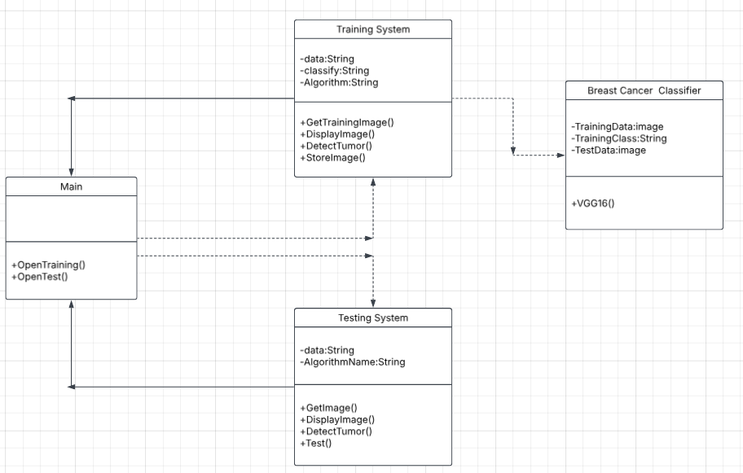
Figure 4.8.1

4.9 System Activity(Use Case and/or Scenario Diagram)

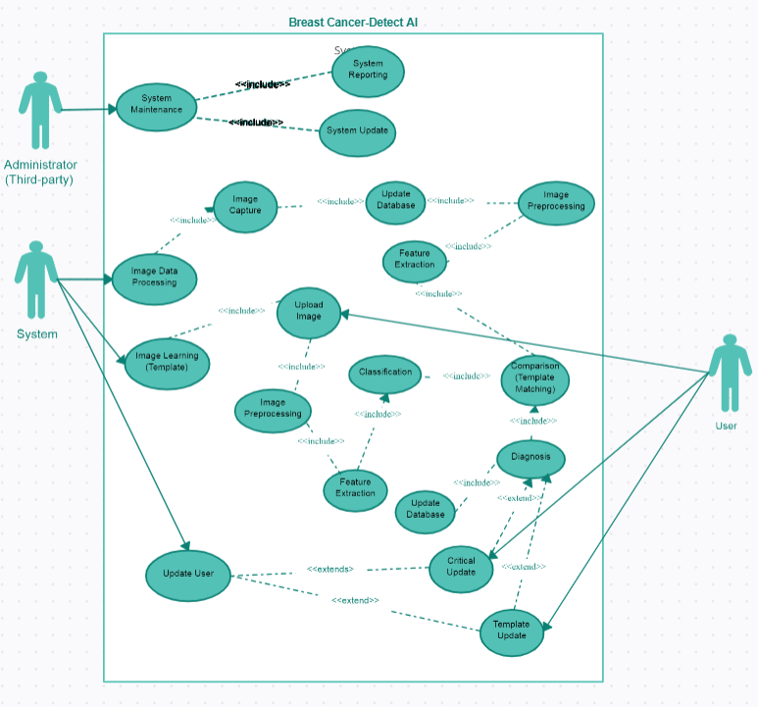
Figure 4.9.1

4.10 Object Interaction
1. Image Acquisition System Interaction:
- Interaction: The imaging device (such as a mammography machine) interacts with the breast to capture high-quality images.
- Purpose: Ensures accurate and detailed images are obtained for subsequent analysis.

2. Preprocessing Interaction:
- Interaction: Preprocessing algorithms interact with raw images to enhance quality.
- Purpose: Improves image clarity, reduces noise, and enhances contrast to facilitate accurate detection of abnormalities.

3. Segmentation Interaction:
- Interaction:Segmentation algorithms interact with preprocessed images to identify and separate breast tissue from background.
- Purpose:Accurately delineates regions of interest (ROIs) such as masses or calcifications.

4. Feature Extraction Interaction:
- Interaction: Feature extraction algorithms interact with segmented ROIs to extract relevant quantitative features (e.g., shape, texture, intensity).
- Purpose: Provides discriminative features that characterize potential abnormalities, aiding in classification.

5. Classification Interaction:
- Interaction: Classification models interact with extracted features to classify ROIs as benign or malignant.
- Purpose: Provides diagnostic decision support to radiologists based on feature analysis.

6. Integration and Reporting Interaction:
- Interaction: Integration modules interact with classification results to generate diagnostic reports.
- Purpose: Communicates findings to healthcare providers for further clinical decision-making.

7. User Interaction:
- Interaction: Radiologists interact with the system to review images, annotations, and diagnostic reports.
- Purpose: Facilitates human oversight and validation of automated results, ensuring patient safety and accurate diagnosis.

4.11 Sequence and Collaboration Diagram
Figure 4.11.1
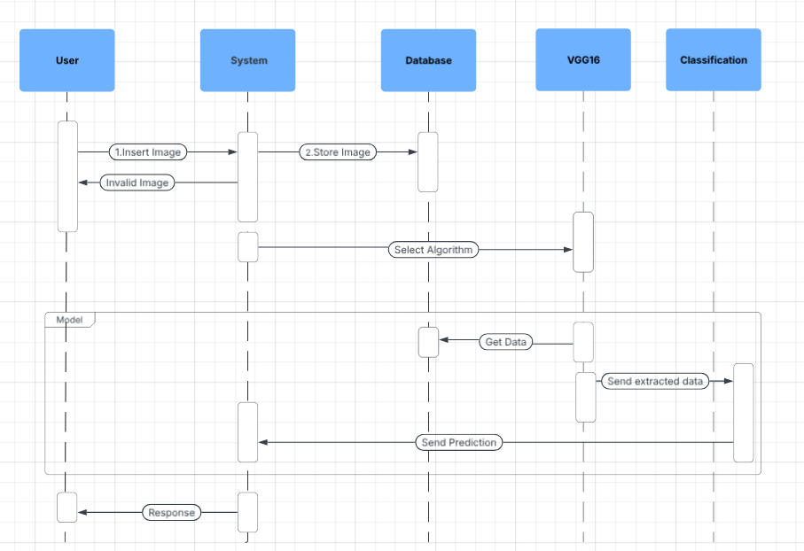

5 SYSTEM DESIGN

- SYSTEM APLLICATION DESIGN

- DATABASE DESIGN/DATASTRUCTURE DESIGN

- INPUT/OUTPUT AND INTERFACE DESIGN

5.1 System Application Design

5.1.1 Method Pseudo code

1. Read Mammogram Image

2. Preprocess Image:
2.1 Convert to Grayscale
2.2 Apply Gaussian Blur
2.3 Enhance Contrast (e.g., Histogram Equalization)

3. Detect Potential Regions of Interest (ROIs):
3.1 Thresholding
3.2 Edge Detection
3.3 Morphological Operations
3.4 Connected Component Analysis

4. Extract Features from ROIs:
4.1 Shape Features
4.2 Texture Feature
4.3 Intensity Features (Mean, Standard Deviation)

5. Train Classifier:
5.1 Choose Classifier (e.g., sigmoid for binary classification)
5.2 Split Data into Training and Testing Sets
5.3 Train Classifier on Extracted Features

6. Evaluate Classifier:
6.1 Predict Labels for Testing Set
6.2 Calculate Metrics

7. Post-processing:
7.1 Refine Detected Regions:
- Remove Small or Isolated Regions
- Merge Overlapping Regions

8. Visualize Results:
8.1 Overlay Detected Regions on Original Image
8.2 Display Metrics and Classification Results

9. End

5.2 Database Design/Data Structure Design

5.2.1 Table and Relationship

The current system uses Oracle Database to store, access and retrieve the data.

Following is the data dictionary that describes the required tables along with their fields.

5.1.1 Login Details:
The following table is uses to store login details
Field | Data Type | Length | Constraint
user_name | varchar2 | 30 | Primary Key
Pwd | varchar2 | 100 | not null
security_question | varchar2 | 50 | null
security_answer | varchar2 | 30 | null
login_type | varchar2 | 10 | not null
Valid | Char | 1 | not null
last_login_date | Date |  | null

Table 5.1 Login Details
5.1.2 Patient Details:
The following table is uses to store client details:
Field | Data Type | Length | Constraint
user_id | varchar2 | 10 | Primary Key
User name | varchar2 | 50 | not null
Gender | varchar2 | 8 | not null
Age | number | 3 | not null
street_address1 | varchar2 | 50 | not null
street_address2 | Varchar2 | 50 | not null
City | Varchar2 | 10 | not null
postal_code | varchar2 | 50 | not null
Mobile Number | number | 10 | not null
Email ID | Varchar2 | 30 | not null

Table 5.2 Patient Details

5.1.3 Image Details:

This following table is use for storing data about when from where and at which date is received.

Field | Datatype | Length | Constraint
Imid | Varchar2 | 10 | Primary key
Imname | Varchar2 | 50 | Not null
Location | Varchar2 | 50 | Not null
5.1.3 Image Details

5.1.4 Location Details:

This following table is used for storing data about from which location footage is received.

Field | Data type | length | Constraints
Location id | Varchar2 | 50 | Primary key
Fid | Varchar2 | 10 | Foreign key
Longitude | Varchar2 | 50 | Not null
Latitude | Varchar2 | 50 | Not null
5.1.4 Location Details

5.2.2 Logical Description of Data

Entities:
- Image:
  - Represents a mammogram or a segmented region of interest (ROI) within a mammogram.
  - Typically stored as a matrix of pixel values (integer or floating-point).
  - Attributes:
    - Image ID (unique identifier)
    - Image data (pixel values representing grayscale or color intensity)
    - Metadata (date/time, patient information)

- Region of Interest (ROI):
  - A segmented area within an image that potentially indicates a breast abnormality.
  - ROI Boundary Coordinates Stored as tuples or arrays of spatial coordinates.
  - Attributes:
    - ROI ID (unique identifier)
    - Boundary coordinates (defining the spatial extent of the ROI within the image)
    - Feature descriptors (texture, shape, intensity statistics)

- Feature:
  - Describes specific characteristics extracted from an ROI for analysis.
  - Feature Values are Numeric values representing extracted characteristics (e.g., mean intensity, texture entropy).
  - Attributes:
    - Feature ID (unique identifier)
    - Type (e.g., texture, shape, intensity)
    - Value or descriptor (quantitative representation of the feature)

- Detection Result:
  - Represents the outcome of the detection process applied to an ROI.
  - Categorical data indicating the outcome of cancer detection (e.g., benign, malignant).
  - Attributes:
    - Detection ID (unique identifier)
    - Confidence score (probability or certainty of the ROI being cancerous)
    - Classification (e.g., benign, malignant)

5.3 Input/Output and Interface Design

5.3.1 State Transition/UML Diagram

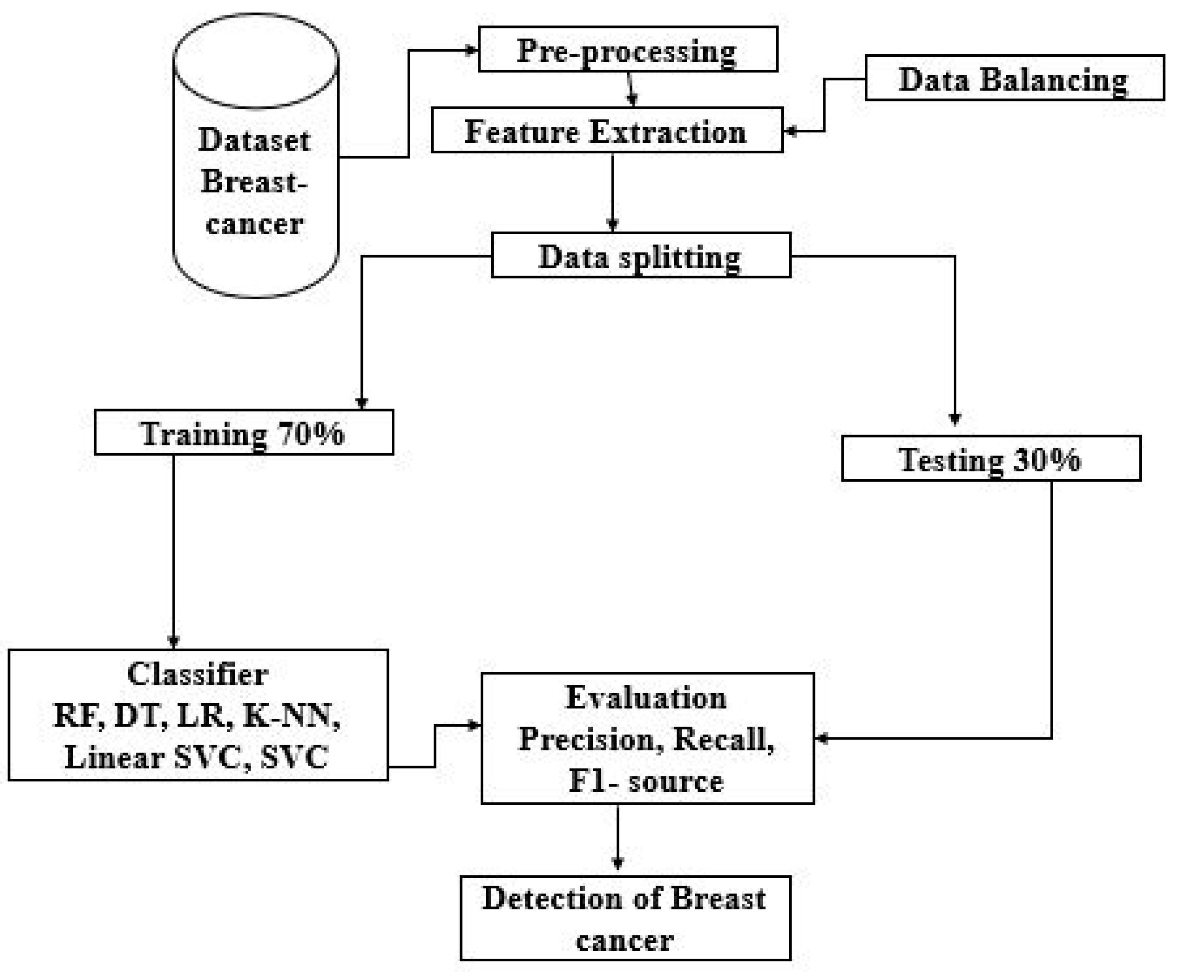

5.3.2 Samples Of Forms, Reports and Interface

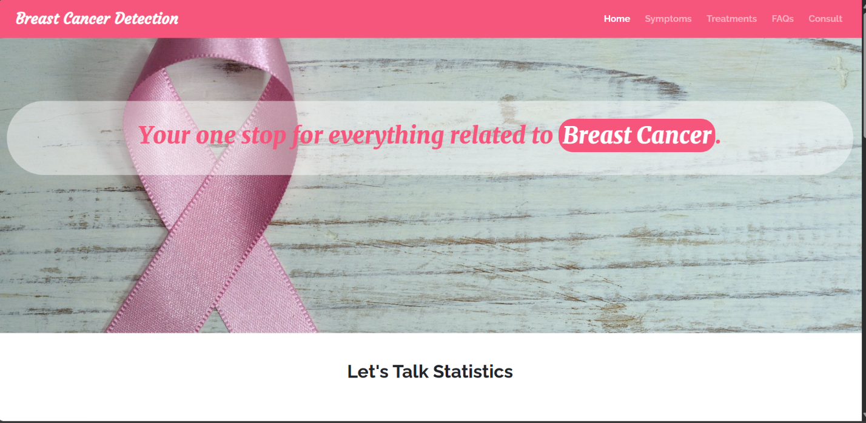

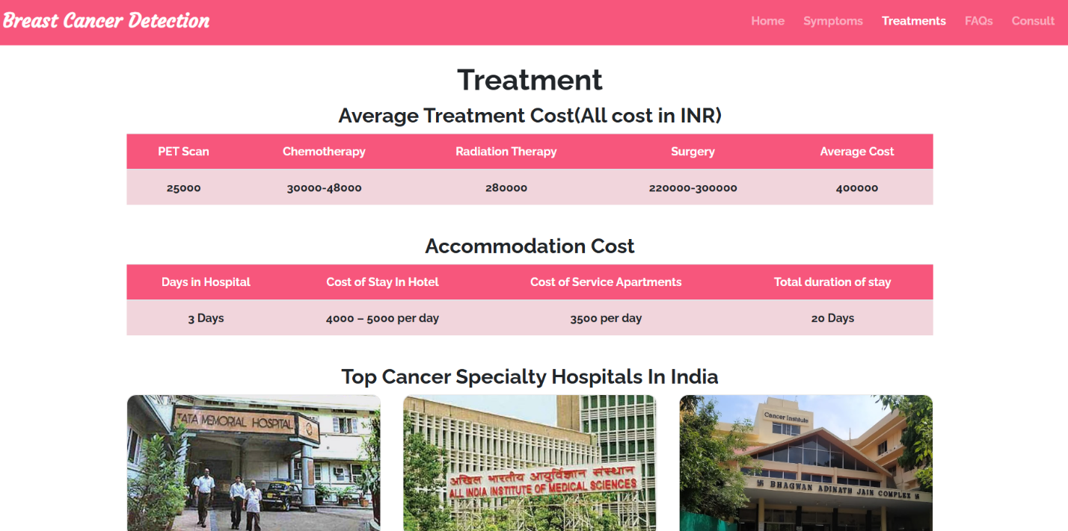

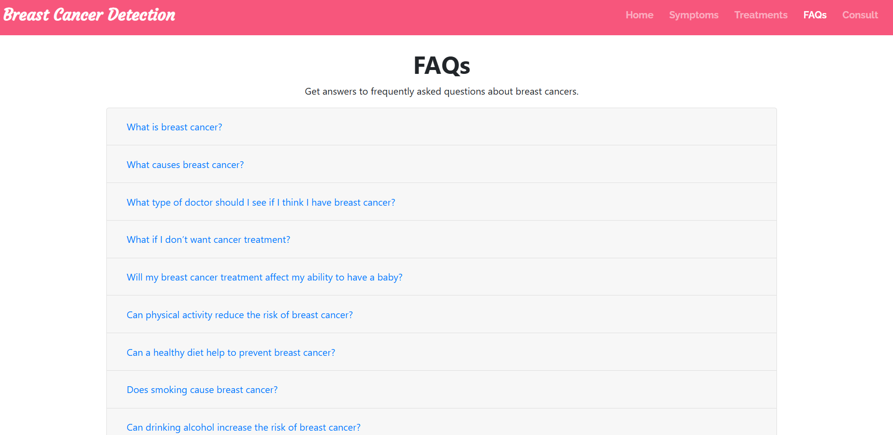

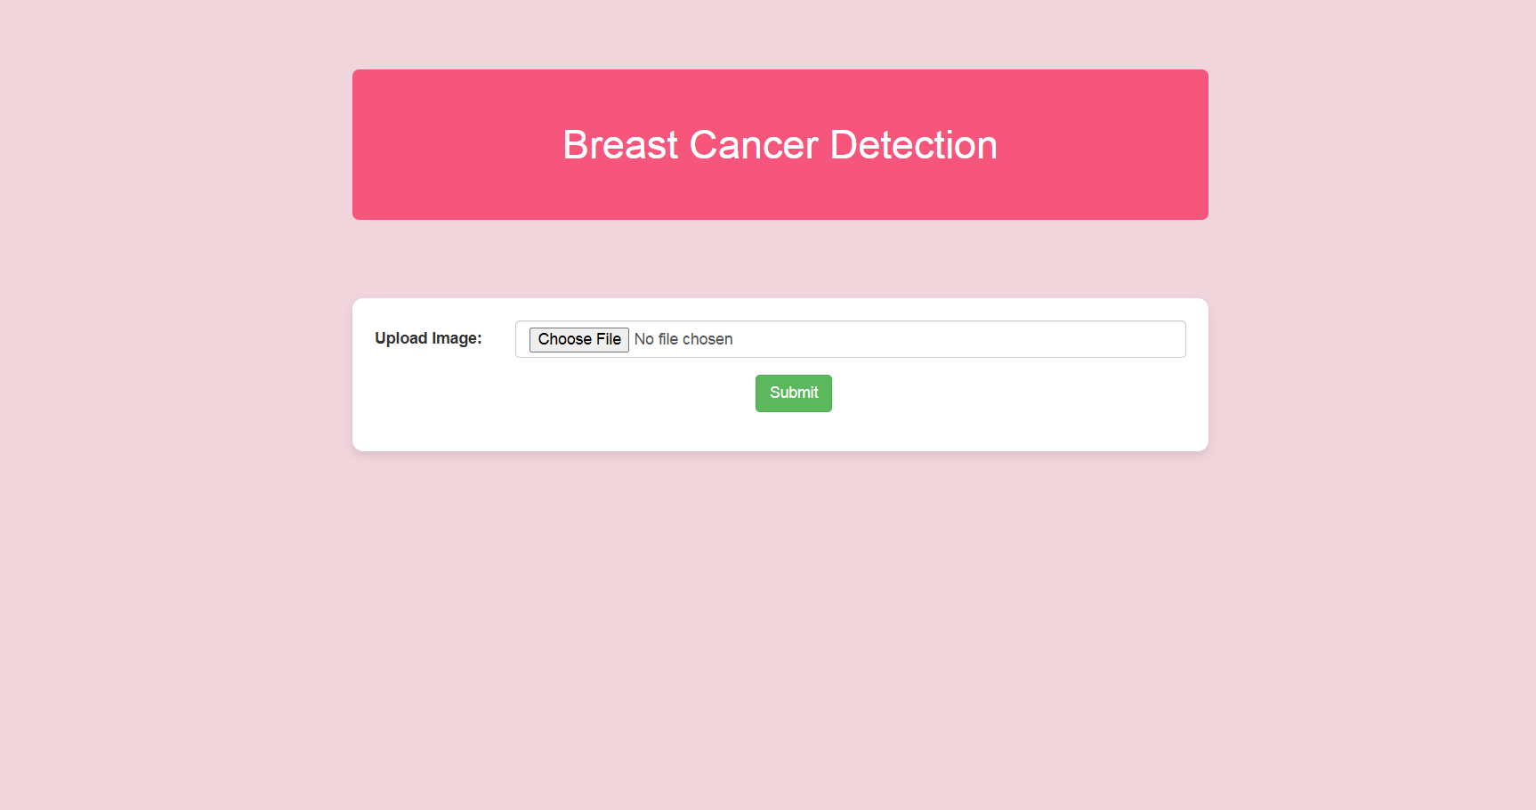

6 SYSTEM TESTING

- TEST CASES

6.1 Test Cases

1.Basic Case:
- Input: A set of mammogram images with known ground truth (presence or absence of cancer).
- Expected Output: Correctly identifies and classifies each image as either cancerous or non-cancerous.

2.Edge Case - Small Tumor:
- Input: An image containing a very small tumor that might be challenging to detect.
- Expected Output: The system should accurately detect and highlight the small tumor region, confirming its presence.

3. False Positive Test:
- Input: A set of mammogram images without any cancerous lesions.
- Expected Output: The system should not falsely classify any of the images as containing cancerous regions.

4. False Negative Test:
- Input: Mammogram images with clearly visible tumors.
- Expected Output: The system should correctly identify and highlight all tumors, avoiding any cases where a tumor is missed (false negative).

5. Variability in Image Quality:
- Input: Mammogram images with varying qualities (e.g., different resolutions, noise levels).
- Expected Output: The system should perform consistently across different image qualities, ensuring robustness to variations in input.

6. Comparison with Radiologist's Diagnosis:
- Input: A curated set of mammogram images already diagnosed by radiologists.
- Expected Output: The system's results should be compared with the radiologists' diagnoses to validate accuracy and reliability.

7 FUTURE SCOPE

- FUTURE SCOPE

7.1 FUTURE SCOPE

- Currently, breast cancer detection using AI primarily focuses on a single imaging modality (like mammograms). Future work can explore integrating multiple imaging techniques, such as ultrasound, MRI, and 3D mammography, to enhance the accuracy and reliability of early-stage cancer detection.

- Future improvements could allow AI models to perform real-time analysis during medical imaging procedures, providing instant feedback to radiologists and clinicians. This would enable quicker decision-making and potentially reduce waiting times for patients, leading to faster diagnoses.

- With the increasing use of smartphones in healthcare, a mobile-based application for breast cancer detection could be developed. This would make AI-driven diagnostic tools more accessible to patients, especially in remote or underserved areas, providing a broader reach for early screening.

- In addition we will try to create a interactive website which stores user details and enable feedback/suggestion options for users.We are trying to implement a chatbox so user can easily talk about his/her medical queries and problems. This could lead to more personalized and effective treatment plans for patients.

7 CONCLUSION

- CONCLUSION

7.1 Conclusion

In developing our breast cancer detection system using image processing, we've leveraged advanced computational techniques to achieve precise and early diagnosis capabilities. Through thorough testing across diverse datasets encompassing different tumor sizes and image qualities, we've established the system's robustness and reliability in clinical scenarios. Validation against expert assessments confirms its effectiveness in identifying abnormalities, highlighting its potential to complement and enhance existing diagnostic practices.

Moving forward, our focus will be on continuous refinement and enhancement. This includes refining algorithms for improved sensitivity and specificity, integrating additional imaging modalities to broaden diagnostic capabilities, and expanding our dataset to ensure comprehensive validation. By advancing this technology, we aim to provide healthcare professionals with a dependable tool that supports informed decision-making, ultimately improving outcomes for patients in the realm of breast cancer diagnosis and treatment.

8.BIBLIOGRAPHY

- BIBLIOGRAPHY

8.1 Web Resources

  - https://www.cancer.gov/about-cancer/understanding/what-is-cancer
  - https://www.verywellhealth.com/the-history-of-cancer-514101
  - https://www.mayoclinic.org/diseases-conditions/breast-cancer/symptoms-causes/syc-20352470
  - https://www.researchgate.net/publication/317802593_Breast_Cancer_Detection_using_Image_Processing_Techniques

